OFFSIDE DETECTION IN SOCCER

A/ Introduction

a/ Motivation

Offside rule is one of the most complicated rule in soccer and difficult to catch up by human which will cause many controversial decisions and ruin the game. Nowadays, camera-system is installed in order to help of referees giving the fair determination. However, for lower league games, the installation of a camera based system is quite expensive and hard to install. Our work has a main purpose to make a system to identify offsides in soccer with the best result and lowest cost.

b/ Offside Rules

Rule : A player is offside when he is in the **offside location** and **at the moment** the ball is played or touched by a team-mate is only penalised on becoming involved in active play.

1/ Offside Location

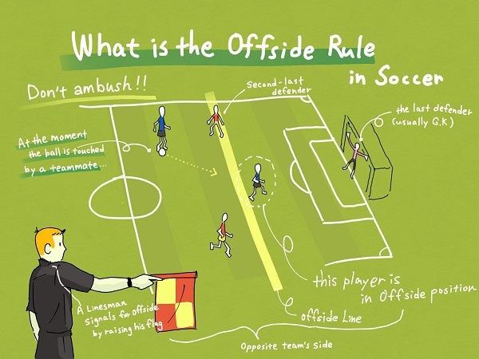

Figure1. Offside Rule

* any part of the head, body or feet is in the opponents half (excluding the halfway line) and
* any part of the head, body or feet is nearer to the opponents’ goal line than both the ball and the second-last opponent

The hands and arms of all players, including the goalkeepers, are not considered. For the purposes of determining offside, the upper boundary of the arm is in line with the bottom of the armpit. Like this below Image

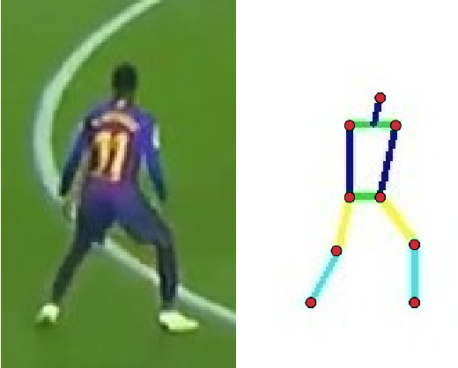

Figure2. Body

A player is not in an offside position if level with the:

* second-last opponent ( including goalkeeper )

2/ Active play

* Attending the active play by playing or touching the ball passed or touched by his/ her teammate
* Intervene with opponents

3/ No Offence

There is no offside offence if a player receives the ball directly from:

* a goal kick
* a throw-in
* a corner kick

c/ General Approach

B/ Plans

a/ Main problem decomposition

1/ Main Problem (Input: video stream, output: “Offside”, “Not offside”)

- Is the player in offside location (2a)

- Is the player in the active play (2b)

- Is the situation is in exceptional situation ( goal kick, throw in,…) (2c)

2a/ Offside location

- How to differentiate team A and team B => using sensor gear

- How to capture the body of the player => heat map, sensor gear, deep learning

- Analyze the location (the player is nearer to the opponents’ goal line than both the ball and the second-last opponent) =>

2b/ Active play

- How to know the player touch the ball or intervene his or her opponent

- Ball detection

2c/ Exception

- How to know these special events (goal kick, throw in, goal line)

3a/ Sensor gear system

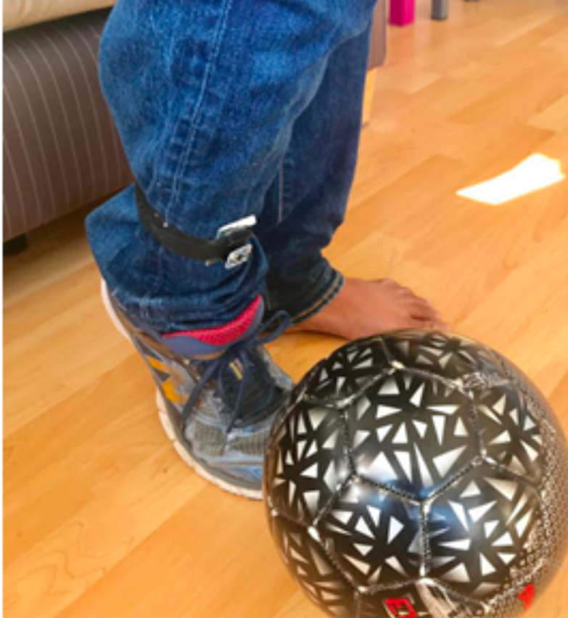

Figure3. Censor Gear

- Must be wearable and easily to put on

- Good device

- Wear to put on ?

3b/ Heat map

C/Refference